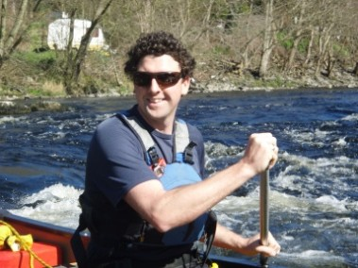*Dordogne in the Spring* (Comfort Option)

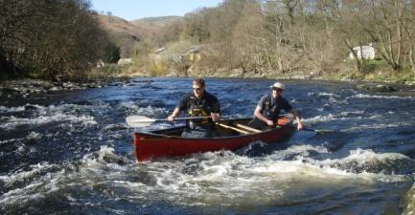*A+ Active Retreats*: ‘Out there - *in Him*’

Itinerary: Wednesday - Saturday – early May 2025

Thursday: Fly Ryan Air Stansted Dep 09.30> Brive/Dordogne arr. 12:15 am.

A+ bus from Airport > riverside guest house.

Lunch is followed by Introductory canoe skills training; Dinner together in the town; River briefing & Evening Thought 1. ‘Sleep well’

Friday: **River Day:** Breakfast. Drive to Argentat to commence Canoe Journey on the Dordogne. Packed Lunch by river. Day 1 Journey approx. 20km.

Return to Beaulieu cabin or guest house and dinner in Beaulieu Sur Dordogne & ‘Out There - *In Him*’ Thought 1: ‘**Rock’.** To bed.

Saturday: **River Day:** Canoe to Riverside cabin or guest house… Packed Lunch by the river. Day 2 Journey approx. 20km.

Evening Meal out in the medieval town. Return cabin or guest house for Out There - *In Him* Thought 1:’ **Water’.** To bed.

Sunday 29th: Early Breakfast and leave at 07.00 in A+ bus for Brive in time for the 15.30 (tbc) flight to Stanstead (arr. 16.00)

**Food & Board**: A+ will book riverside camping cabin or a small French B&B. Packed lunch will be provided by A+. Party eats out together each evening at local restaurants & hostelries in the delightful medieval town of Beaulieu-sur-Dordogne (not included in the price).

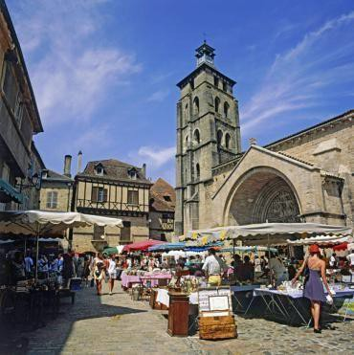**£445pp includes: Airport Pick-up · Accommodation & Lunches · Canoe kit hire · Coaching & River Leading.**

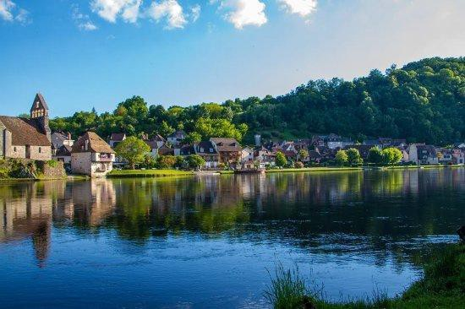*This is a reduced price as we blaze a new trail together with our first-ever group in the Dordogne!* ***Live the Adventure!***

Kit list to follow. Travel to & from Brive is not included.

**A+ Active Retreats:** An island in the fast flow of modern life.

Take a rest and learn new outdoor skills.

Some will also want to take the opportunity to reset priorities & their focus before returning to home, church and work life as we journey together…

**Out there *– In Him:*** *Getting out into the beauty of this wonderful world God has given us to enjoy, be refreshed & encouraged.*

*A chance to reflect on the characteristics of the Creator God, as revealed in His Creation and described in the bible.*

**Canoeing Kit list provided by A+**: Boat Buoyancy Aid Helmet Paddle & Spare Kneeling Mat Bailer & Sponge

**Journeying kit list:**

Comfortable clothes for canoeing (not cotton) in warm & cool weather

Watersports shoes (not open toe sandals) and dry spare shoes for evenings

Waterproof socks (optional for cold weather), wide-brim sun hat & warm hat

Waterproof coat & trousers & warm fleece

Sleeping bag & pillow case

Wash bag, light towel, skin cream, lip balm

Head torch (spare batteries) & waterproof camera

Tea towel & washing up sponge

Day water bottle & lunch bag or lunch box

Personal 1st aid kit/meds,

Small Bible & diary / note book to record thoughts as we go

Large (>60 l)**\*** and small (20 l) dry bags(plus thin ‘lining’ dry bags)

Phone Charger (tho we aim to keep phone use to a minimum whilst on the river)

**\*** *Can be hired from A+*

**A+ Provides**:

AND DON’T FORGET YOUR **PASSPORT** & **DRIVING LICENSE**

Also your EHIC Card if you have one and evidence of & European Travel Insurance

**FAQs.**

***How does cooking work?*** A+ will provide continental breakfast & packed lunches. Participants are responsible for evening meals, aiming to eat out each evening in a local restaurant or hostelry. Evening meals are not included in the price of this trip.

***How about sanitation?*** There are no WCs during the day on the rivers so participants are asked to make their own arrangements for their comfort during the day. Participants bring tissues and hand/gel/soap etc.

***Will we have enough water?*** The weather could be very warm (that would be nice ☺) so let’s each bring two large water bottles for rehydration each day.

***What is provided at our accommodation?*** See kit list above.

***Why do we need to get sponsorship too?*** French authorities recently declared that only French canoe coaching quals are now valid on their rivers. UK coaches may not coach on their rivers, but it is possible to organize a sponsored exped. to support a community organization, and of course that trip needs appropriate safety cover, which is being provided by A+. Participants a\re also asked to raise some sponsorship for this 60km canoe trip down the Dordogne (or another French river, if river levels dictate a change of venue)… and the sponsorship will be used to help A+ replace and replenish activity kit used on this trip and by over 6,000 children and young people each year– so go for it on the sponsorship. It will provide real encouragement and support for our work at A+.

***Is it possible to travel from UK in A+ minibus?*** A+ is offering 2 events in the week with a ‘Comfort Option, staying in a gite or cabin in Beaulieu from Thursday to Sunday. The A+ minibus will be leaving on Thursday prior to the Wild Camping week, and staying in the area until Monday following the Comfort Option. There is then 1.5-2 days’ travel either side. There is space for one or two to travel in the van, one way or both, especially if they are happy to assist with driving. A contribution to fuel and ferry fare would be added. We may stop to sleep in the van en route.

You’re A+ Trip Leader is: Jon Cox

Jon is an experienced expedition leader, on rivers and in the hills. He loves nothing more than journeying with people to help them learn new skills and to be comfortable in the outdoors so they are then free to enjoy the journey and be open to fresh insights into the intricacies, patterns and beauty of this wonderful world God has created for us to enjoy – and to care for. Jon is a Level 4 white water Canoe & Kayak Coach, Senior Sea Kayak Instructor and Mountain Leader.

If you have any questions or need any other information, please don’t hesitate to be in touch: [jon@adventureplus.uk](mailto:jon@adventureplus.uk) 0776 151 4802

“*I am already looking forward to journeying with you in such a beautiful and entertaining river environment*”